Figure 1: homogeneous set up for the 1D Modflow set up

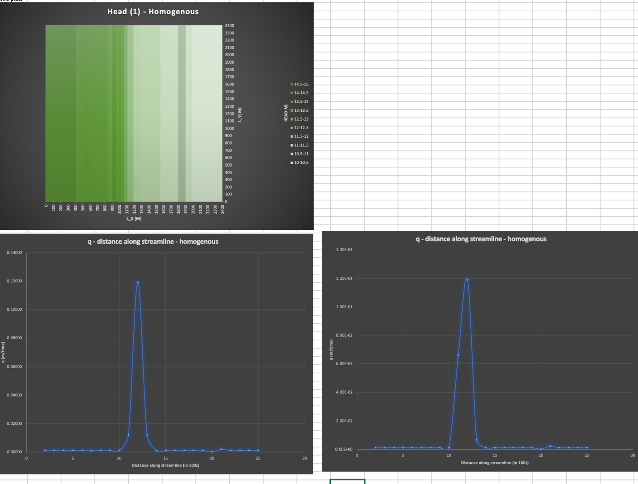

Figure 2: Heterogeneous Example with K = 10 m/day in column 11 and 12

Figure 3: Box in the middle of the grid with a K value of